School of Health and Social Care, Early Years and Education

Riverside College is an outstanding (Ofsted 2024), highly popular and successful further education college conveniently located in Widnes and at the hub of the Mersey Gateway, within easy reach of Liverpool, Manchester and Chester. We currently cater for over 3,000 16-18 students, 600 full time adults, 700 apprentices, and deliver a range of Higher Education and part time adult courses.

The Health and Social Care and Early Years department offer an exciting curriculum and have strong employer engagement. This provides the opportunity to understand the requirements of the sector and prepares students for work placement.

The School of Health and Social Care offers the following programmes:

• Apprenticeships at all levels
• Health and Social Care Level 1
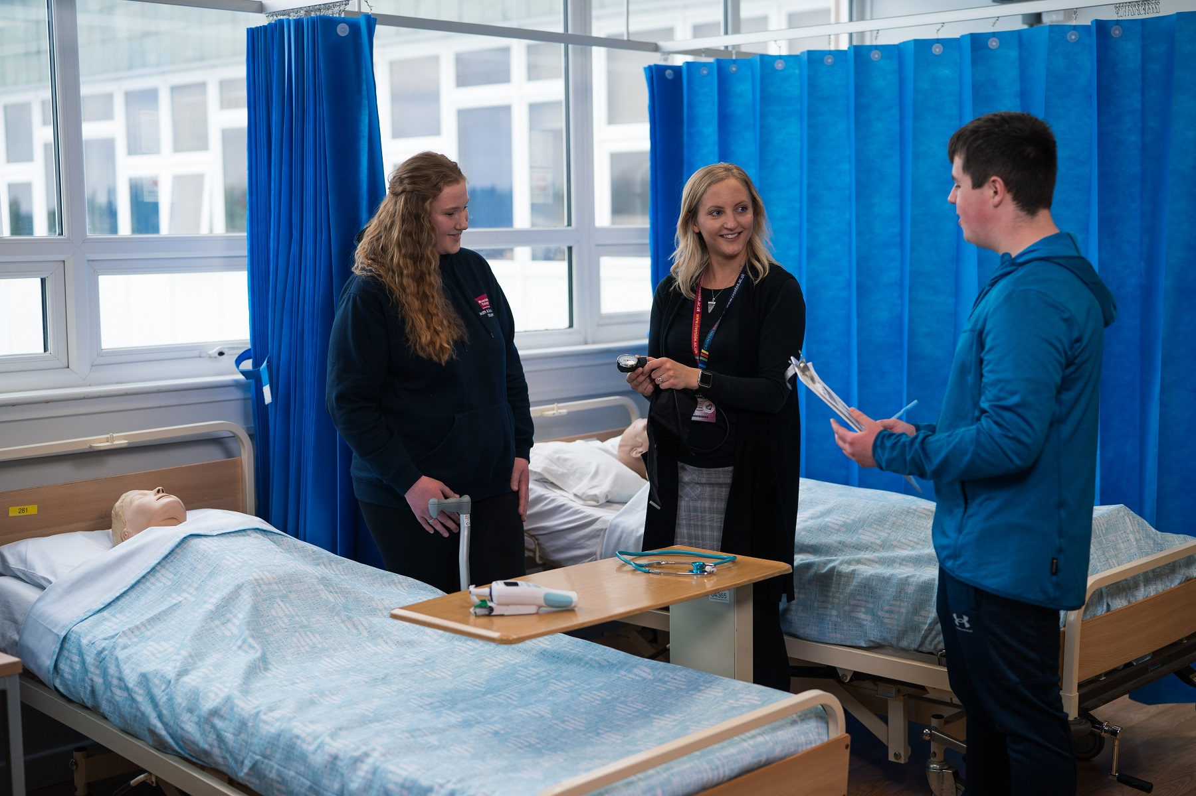
• Health and Social Care Level 2 NQF
• Health and Social Care Level 3 Extended
• (Health and Social Care Pathway)
• Health and Social Care Level 3 Extended
• Diploma (Health Studies Pathway)
• Counselling Level 2 & 3
• Counselling Foundation Degree
• Various Health related short courses

The School of Early Years and Education offers the following programmes:

- NCFE Level 2 Certificate in Early Years and Education and Care.


- NCFE level T level in Assisting Teaching.

- NCFE Level 1 Introduction to Children and Young People.

- NCFE Level 2 Certificate in Supporting Teaching and Learning in Schools.

- NCFE Level 3 Diploma in Specialist Support for Teaching and Learning in Schools.

- Foundation Degree in Education.

Following an Ofsted inspection in April 2024, the College has been given the highest possible rating of OUTSTANDING by Ofsted for a second time. After a meticulous review of the College, inspectors made the following judgements:

OVERALL EFFECTIVENESS | OUTSTANDING
The quality of education | Outstanding
Behaviour and attitudes | Outstanding
Personal development | Outstanding
Leadership and management | Outstanding
Education programmes for young people | Outstanding
Provision for learners with high needs | Good
Adult learning programmes | Outstanding
Apprenticeships | Outstanding

What is it like to work at Riverside College?
Inspectors said:

"Senior leaders and managers have a very clear rationale for their aspirational curriculums. “

“Leaders carefully consider the courses they provide for students, apprentices and those who have high needs.”

“They have a strong sense of community and are passionate to provide life-changing opportunities for young people and adults, many from disadvantaged backgrounds, to achieve their personal and career goals."

"Staff feel appreciated for the contribution they make to the college."

“Students and apprentices enjoy their learning at Riverside. They display extremely positive attitudes and would recommend the college to friends, family and peers.”

Outstanding results 2024:
99% A Level Pass Rate
99% Level 3 Pass Rate
100% in 29 A Levels
100% in 20 Vocational Subjects (including BTEC and UAL)

Over recent years, significant investments have been made in teaching and learning and support for students, which we believe are key to our success.

Riverside College is committed to:

- Providing learning experiences of outstanding quality

- Investing in teaching, learning and assessment

- Offering students distinctive and valuable opportunities to develop personally and professionally and academically

- Supporting every individual student to reach their full potential

Thank you for your interest in Riverside College. If you would like further information or an informal discussion please contact Jo Burton, Head of Health and Social Care and Early years and Education on 0151 257 2800.
